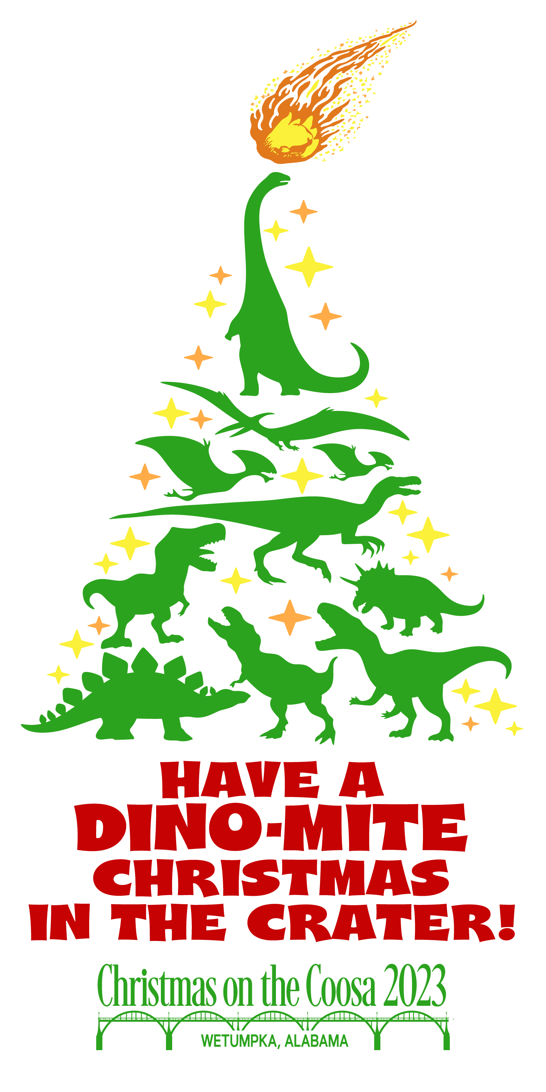
2023 CHRISTMAS ON THE COOSA
NIGHT PARADE APPLICATION & CONTRACT

Saturday, December 9, 2023, 7:00 p.m.
Downtown Wetumpka
Follow our Facebook page for updates: Wetumpka Christmas on the Coosa

(PLEASE PRINT CLEARLY)

Contact Name:
Entry Name:
Mailing address:
City, State, Zip:
Phone #: Cell #:
Email:

TYPE OF ENTRY
BAND (name)
Marching Unit
Vehicle(s)
Motorcycles (how many) _____
Other
Float Will float be judged? yes no Approximate size:_____
Specific information about entry, sponsor or organization. (Example: name of church/pastor, group name/officers, service to community, etc.) This information is used to announce entry as it passes the viewing stand.

Entries must be received no later than Friday, December 1, 2023.
Mail application and all entry fees to: Christmas on the Coosa, P.O. Box 936, Wetumpka, Alabama 36092 or deliver to the City of Wetumpka Administrative Building, 408 South Main Street (located next to the Wetumpka Civic Center).

Signature _____________________________________________ Date ______________________________
For more information, please contact the COTC office at 334-567-5147, email Nicole at ndodd@cityofwetumpka.com, visit www.wetumpkaal.gov, find us on Facebook (Wetumpka Christmas on the Coosa).

IMPORTANT!
Please read all rules before completing the application.
A Dino-Mite Christmas

Night Parade Rules and Regulations

- Fee for all commercial or business entries is $20, which should be submitted with the application.
- Parade registration deadline is Friday, December 1, 2023, 2 p.m. Applications MUST be completely filled out and submitted to the Christmas on the Coosa office.
- Only one entry or unit is allowed for each application. Parade participants MUST follow all rules. Failure to do so will result in removal from parade line-up or route. In the event of inclement weather, parade may be cancelled for the safety of everyone involved. Refunds will not be made in the event of cancellation.
- Parade units MUST BE ILLUMINATED! LIGHTS ARE REQUIRED ON ALL FLOATS! Parade units/participants must provide their own generator. QUIET GENERATORS ONLY!
- Parade units must be fully decorated with Christmas decorations or a Christmas theme with signs on both sides stating the name of the group or organization. Participants are encouraged to decorate around this year’s official theme “A Dino-Mite Christmas.” Floats should have at least one adult designated walker per side to ensure no one darts into parade traffic. Floats will be judged at the Wetumpka football field at 3:30 p.m. Float categories are listed on the back of this sheet.
- No parade unit may include a LIVE Santa or Mrs. Claus.
- Parade participants must be in their assigned street positions by 5 p.m. on Saturday, December 10, 2022. Street assignments will be printed in The Wetumpka Herald and online the week of the parade.
- Street captains will issue parade identification passes. If practical, the numbered pass MUST be displayed during the entire parade route. If it is not practical to display, the pass must remain in possession of the participant and presented to police or parade official(s) upon request.
- Vehicles that are otherwise street legal must be insured as required by Alabama law and driven by driver(s) with a valid driver’s license. Driver’s license and evidence of insurance (which should be kept with the vehicle) must be displayed to police and parade official(s) upon request.
- The parade will end at Love Lane. Floats may drop the float riders off at the Wetumpka Civic Center parking lot. Parents may pick up their children in the designated area in the Civic Center parking lot. Band members should promptly proceed to buses.
- Throwing candy, toys or any other objects from any unit creates a safety hazard for children and is prohibited.
- No loud mufflers.
- ABSOLUTELY NO music not conforming to conventional standards of decency, including, but not limited to vulgarity and profanity, will be allowed. Participants are encouraged to play Christmas music or no music at all. Hanging out of or sitting in vehicle windows is prohibited. Failure to comply with all rules and cooperate with parade officials will result in removal from parade line-up or route. Christmas on the Coosa is an official function of the City of Wetumpka. For additional information, call 334-567-5147 or email Nicole Dodd at ndodd@cityofwetumpka.com.
- The City of Wetumpka is not responsible for any injury, accident, loss or damage that may occur during Christmas on the Coosa activities. The City of Wetumpka reserves the right to deny participation on the day of the parade to any entry not conforming to parade rules and regulations.
- Mail application and all entry fees to: Christmas on the Coosa, P.O. Box 936, Wetumpka, Alabama 36092 or deliver to the City of Wetumpka Administrative Building, 408 South Main Street (located next to the Wetumpka Civic Center).

We encourage you to have a great time and enjoy the day, but most of all be safe and courteous!

Christmas on the Coosa Float Judging

- Winner(s) and first runner(s)-up in each category will receive a framed certificate. Banners will be placed on the winning float(s) to designate their placing for the parade, but must be turned in to parade official(s) at the end of the parade route.

COOSA AWARD (Best overall)
MAYOR’S AWARD (Most original)
NOEL AWARD (Best religious theme)
SANTA’S AWARD (Best children’s theme)
BEST ILLUMINATED AWARD (Best display of lights)

- Floats are judged on their relationship to the overall theme “A Dino-Mite Christmas” in the areas of creativity, originality and workmanship.
.

